The APG focuses on peer support for both the young adult and their family members with emphasis on self-awareness, decision making skills, and day-to-day recovery maintenance skills that assist in obtaining and maintaining a healthy lifestyle. Peer Groups vary by age/developmental stage and are offered to young people between the ages of 12-20 years of age, and are looking to build a same age sober social support system.

* All youth peer leader supports have completed our mentoring program and State required trainings

Our Services
- Peer Based Recovery Groups
- Peer Based Family Groups
- Immediate Sober Support System
- Mentoring/Academic Support
- Weekly Sober Social Events
Daily “Open Door Hours”
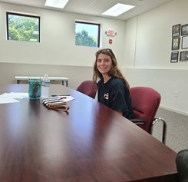
Peer Leader Desiree

Peer Leader Support
This service is provided by a young person (18+), supervised by a Licensed Clinician, who is trained to strategically use their own lived experiences to inspire other young people to take action towards creating better outcomes for their future.

By working with a same age peer leader, adolescents have an immediate built in sober support system. Our peer leaders have established and maintained their own recovery in a variety of academic and occupational settings and model these behaviors and coping techniques for our adolescent clients.

For Families
Our family program is specifically designed to meet the issues faced by family and friends of Adolescents with addiction and alcoholism. It is confidential and frequently utilized by those whose loved ones are not able to maintain recovery or have not entered into recovery.
Don't hesitate to contact us, even if you just want some information or a little advice. There are no lost causes in recovery. And remember, hope is a good thing.
“Our son was headed on a path to substance abuse, and Live Free Recovery provided him with expert clinical and peer support that led to his successful recovery, he now embraces a future without the influence of drugs.”
“staff's pragmatic yet caring support was exactly what our teenage son needed - for him the fact that he could meet and talk with other teenagers who knew his experience was perfect. He is headed to college soon”
“ I was 16 when I was involved in a single car drunk driving accident. I met LFR where they guided me through the challenges of early recovery as a teenager. I'm so grateful for the opportunities and connections this company has provided for me”
Live Free Recovery Consultants
2 Puzzle Lane BLDG 2 Unit 1
Newton, NH. 03858
info@livefreerecovery.com 603.702.2461
Live Free Recovery Consultants
We Proudly Accept
All Major Insurance and
NH. Medicaid

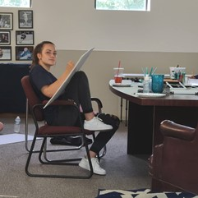
Peer Leader Elizabeth

Live Free Recovery Consultants 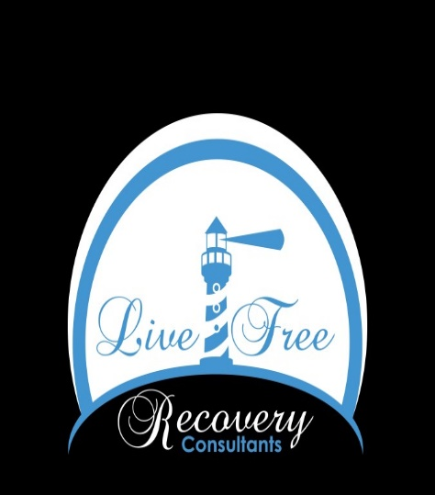
Alternative Youth Peer Group
First of its kind in New Hampshire!!!!
603.702.2461
livefreerecovery.com/adolescent-treatment

