Our experience allows us to educate Adolescents and their families in all aspects of the recovery process. Traditional adolescent programs "teach" you how to get sober then send you on your way. Our unique clinically supported peer leader support program means you work together with a clinician and a peer support. There is no gap between treatment and how it is applied in the real world. As goals are developed with your clinician you are implementing them with your peer support. And with 24-hour access to our staff, there is always someone available should you need guidance
* All youth peer leader supports have completed our mentoring program and State required trainings

Our Services
- Clinically Supported Peer Leader Supports
- Family Coaching
- Relapse Prevention
- Mentoring Program
- 24-hour Access
- Unlimited Lifetime Contact
- Academic Tutoring

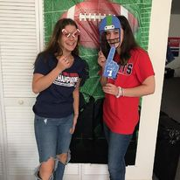

Peer Leader Support
- Clinically Supported Peer Leaders
- Twice Weekly Face to Face meetings
- Recovery Education
- Family Education
- Individual Recovery Plans
By working with a same age peer leader, adolescents have an immediate built in sober support system. Our peer leaders have established and maintained their own recovery in a variety of academic and occupational settings and model these behaviors and coping techniques for our adolescent clients.

For Families
Our family program is specifically designed to meet the issues faced by family and friends of Adolescents with addiction and alcoholism. It is confidential and frequently utilized by those whose loved ones are not able to maintain recovery or have not entered into recovery.
Don't hesitate to contact us, even if you just want some information or a little advice. There are no lost causes in recovery. And remember, hope is a good thing.
“Our son was headed on a path to substance abuse, and Live Free Recovery provided him with expert clinical and peer support that led to his successful recovery, he now embraces a future without the influence of drugs.”
“staff's pragmatic yet caring support was exactly what our teenage son needed - for him the fact that he could meet and talk with other teenagers who knew his experience was perfect. He is headed to college soon”
“ I was 16 when I was involved in a single car drunk driving accident. I met LFR where they guided me through the challenges of early recovery as a teenager. I'm so grateful for the opportunities and connections this company has provided for me”
Live Free Recovery Consultants
2 Puzzle Lane BLDG 2 Unit 1
Newton, NH. 03858
info@livefreerecovery.com
603.702.2461

We Proudly Accept
All Major Insurance and
NH. Medicaid

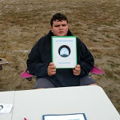

Live Free Recovery Consultants
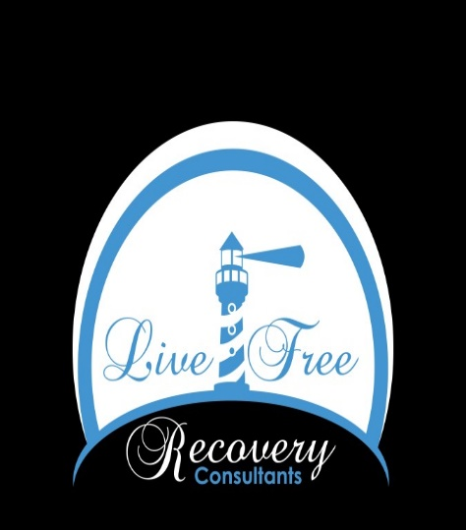
Adolescent Intensive Outpatient Treatment Program with Peer Recovery Support

603.702.2461
livefreerecovery.com/adolescent-treatment

